ML ASSIGNMENT 1

**TASK 1**

In your terminal,

run >> conda info 1

and paste the result into your report.

**OUTPUT:**

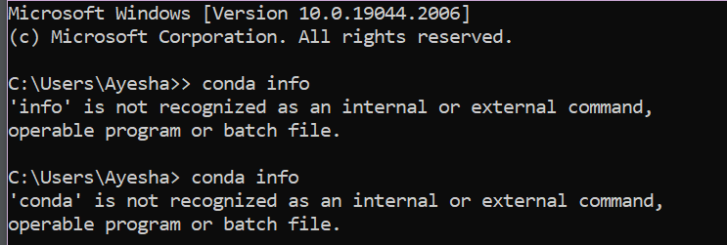

**TASK 2**

Run the following script in IPython and paste the figure created by the script into your report.

import matplotlib.pyplot as plt

plt.plot([1,2,3,4], [1,2,7,14])

plt.axis([0, 6, 0, 20])

plt.show()

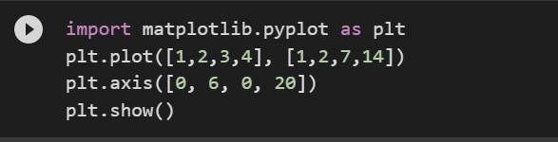

**OUTPUT:**

**TASK 3**

Use Matplotlib to create a figure of your choice in IPython. Paste your code and figure into your report.

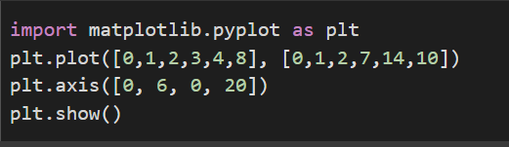

**OUTPUT:**

**TASK 4**

Register for a student account here for free private repository access for future

projects and go through these tutorials. Insert a screenshot of your user page

in github in your report.

